Predict automobile price with the designer

* Create a new pipeline.
* Import data.
* Prepare data.
* Train a machine learning model.
* Evaluate a machine learning model

Create a new pipeline

1. Create a new workspace

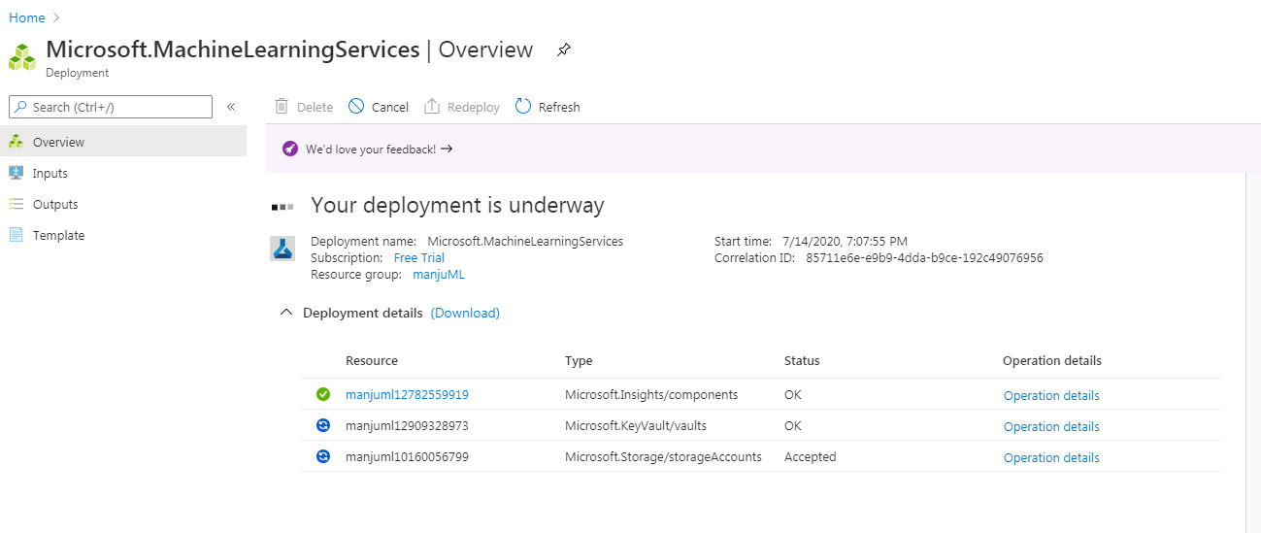

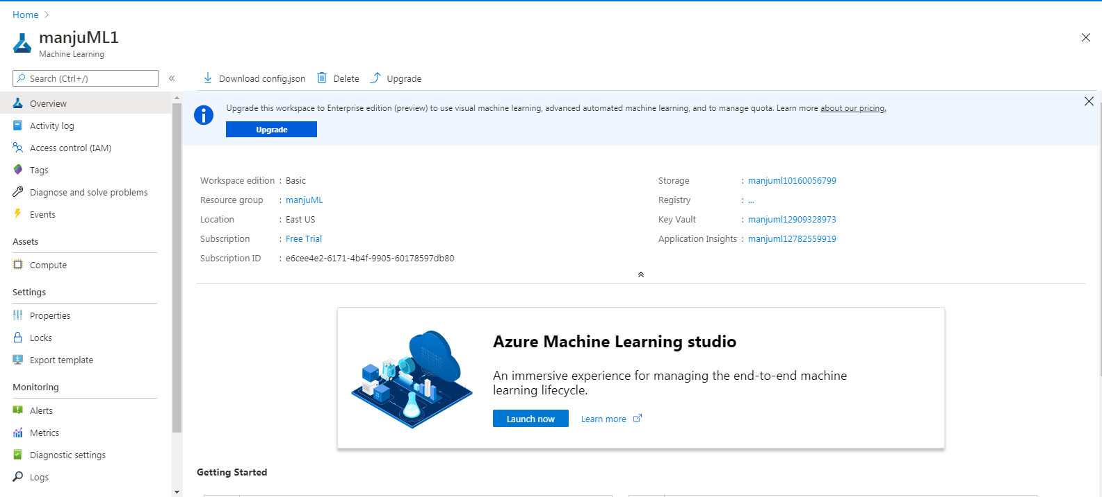

2. Create the pipeline

Sign in to ml.azure.com, and select the workspace you want to work with.

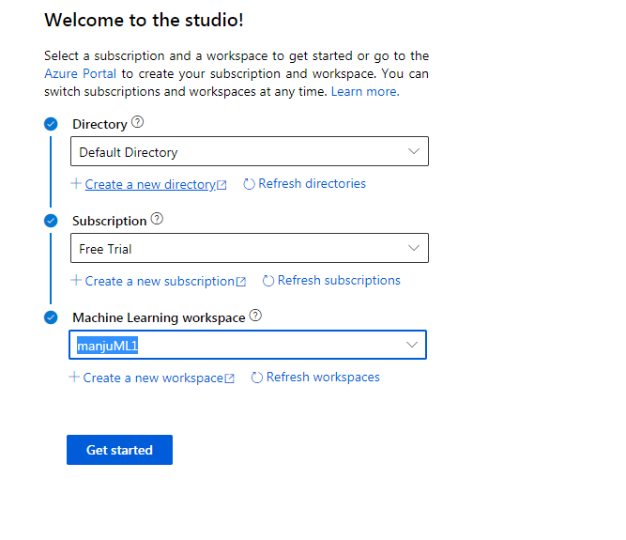

The screen that appears are:

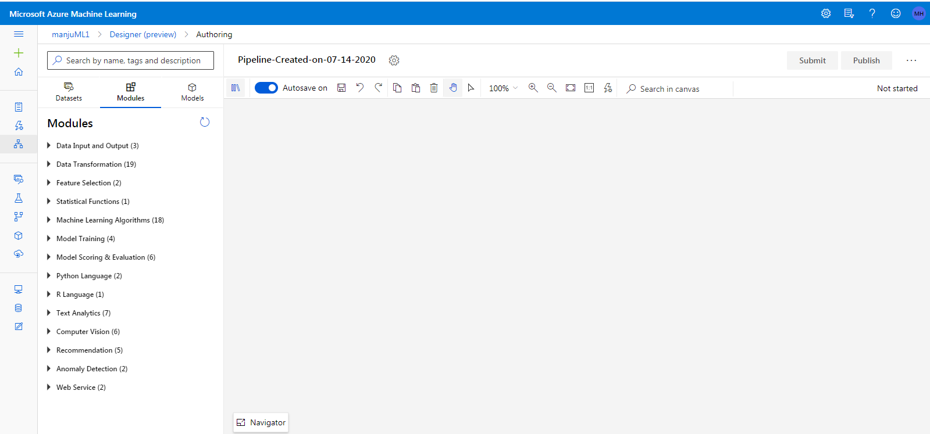

3. Set the default compute target

Create a VM first time

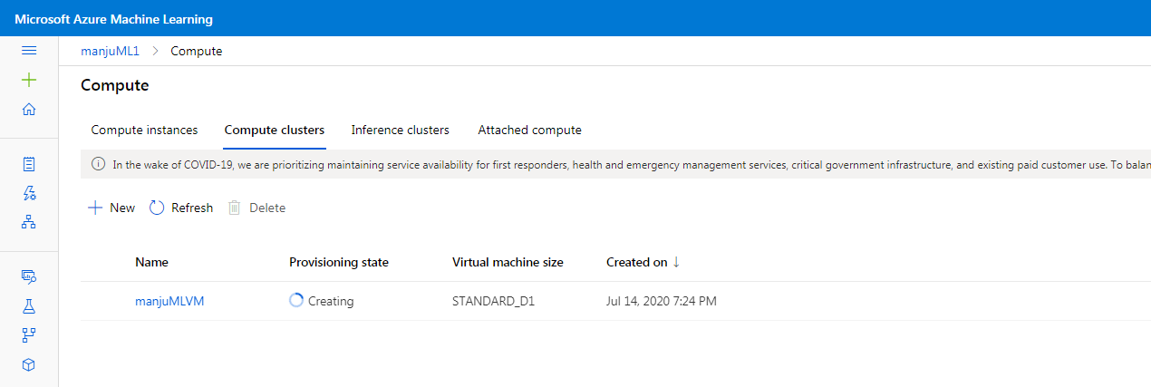

4. Import data

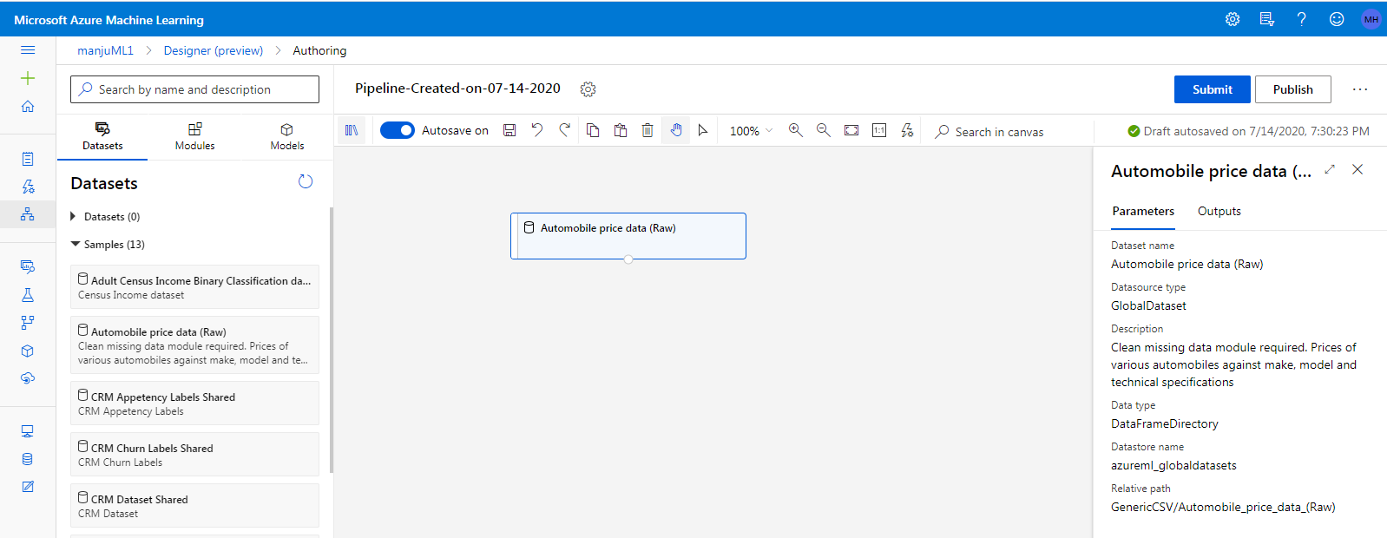

5. Visualize the data

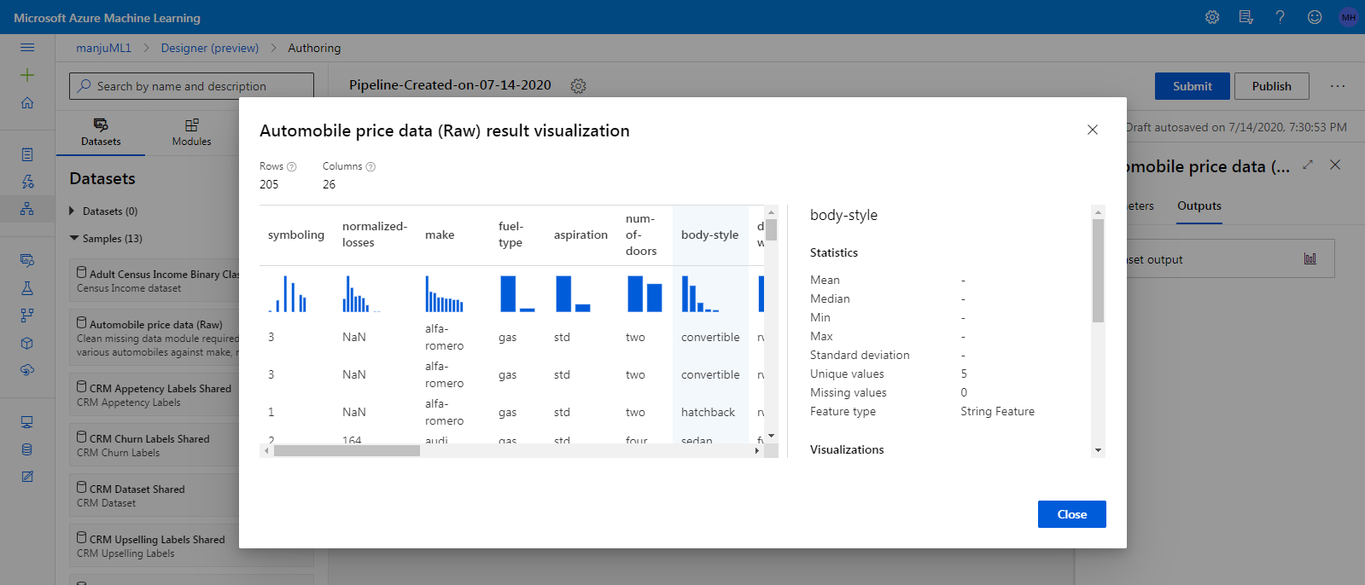

6. Prepare data  
Clean the data and remove the missing values

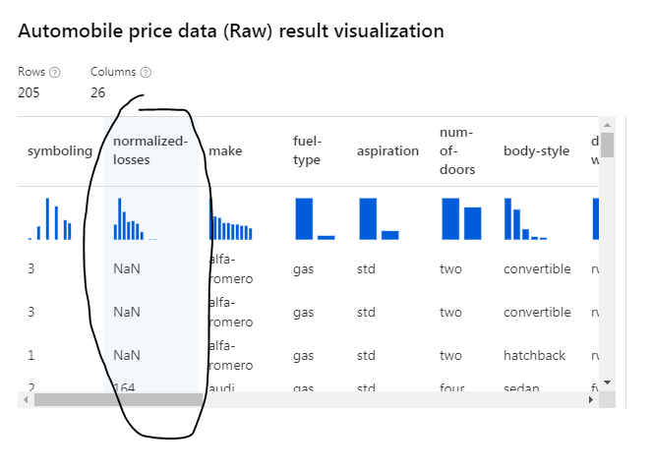

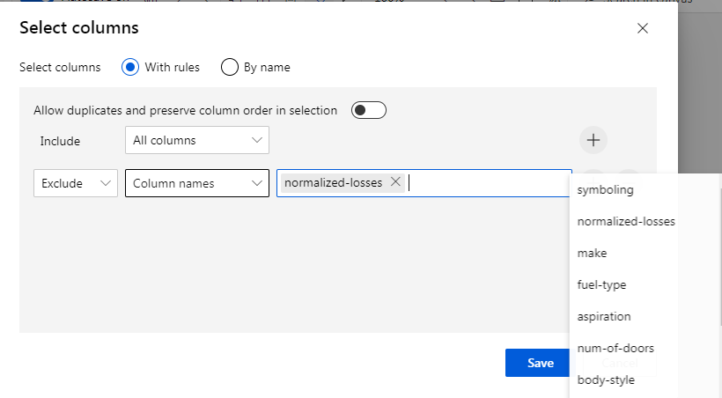

5. Clean missing data

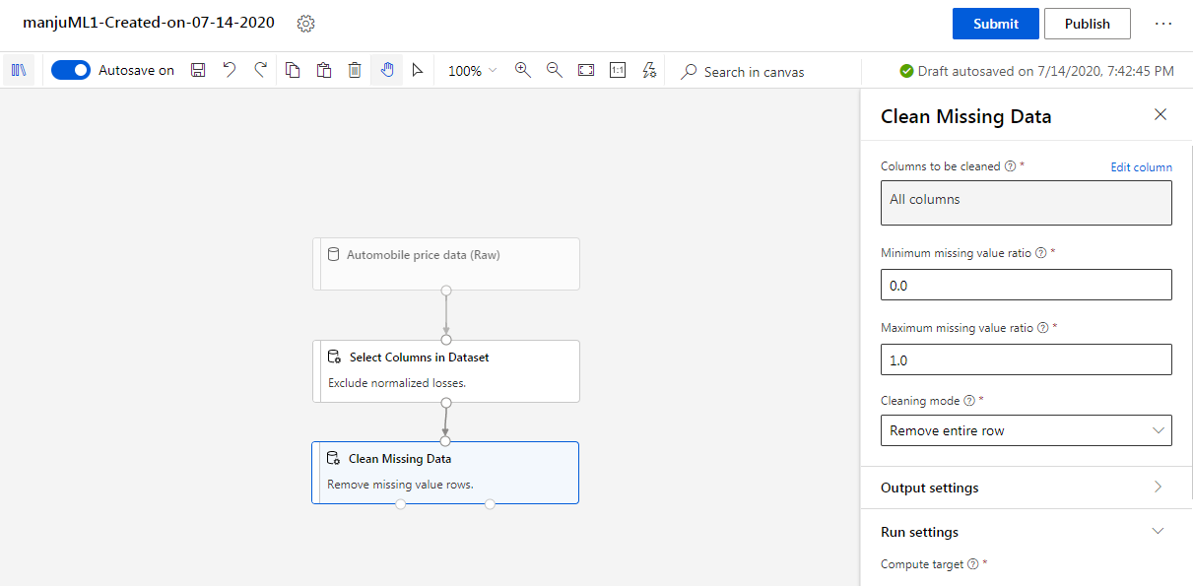

Train a machine learning model

1. Split the data

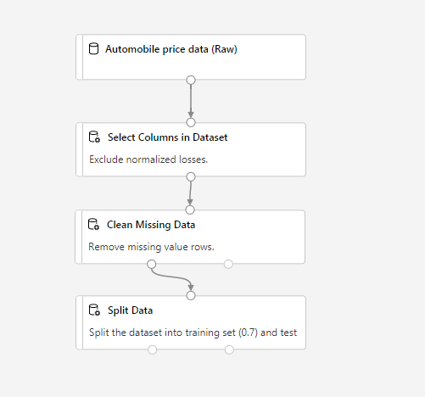

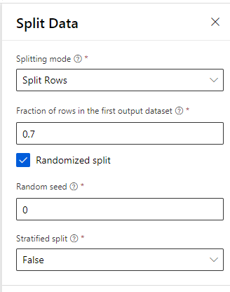

2.Train the model

So the model now looks like

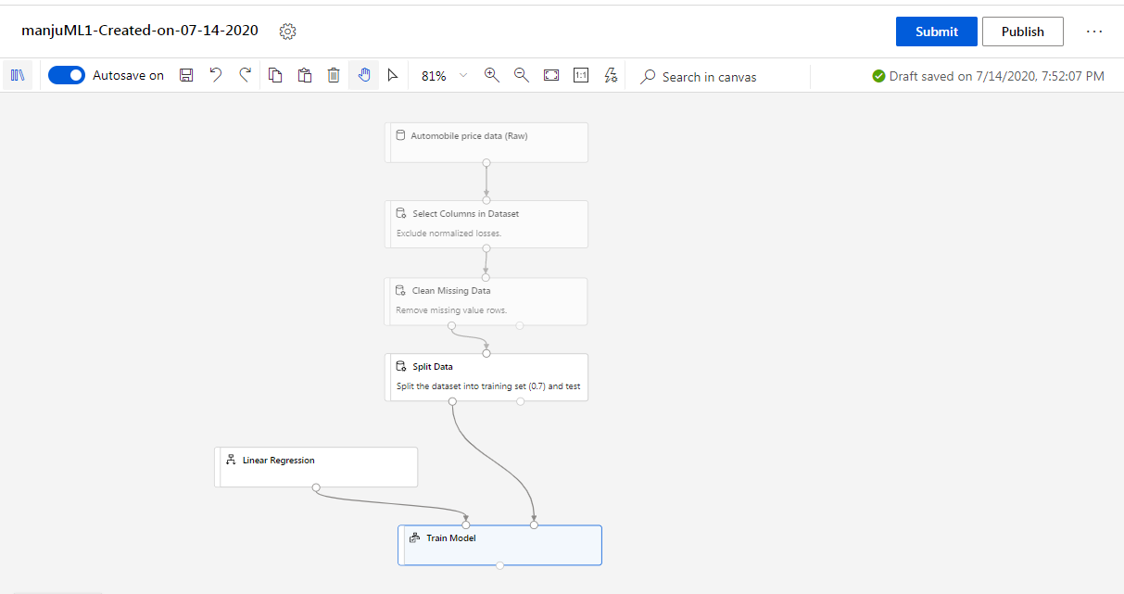

Add the Score Model module

Here test the model on 30% data -> test data.

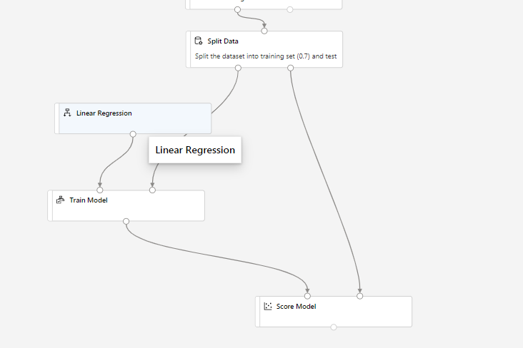

Add the Evaluate Model module

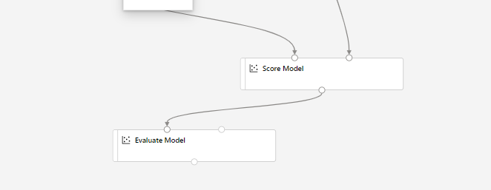

Submit the pipeline

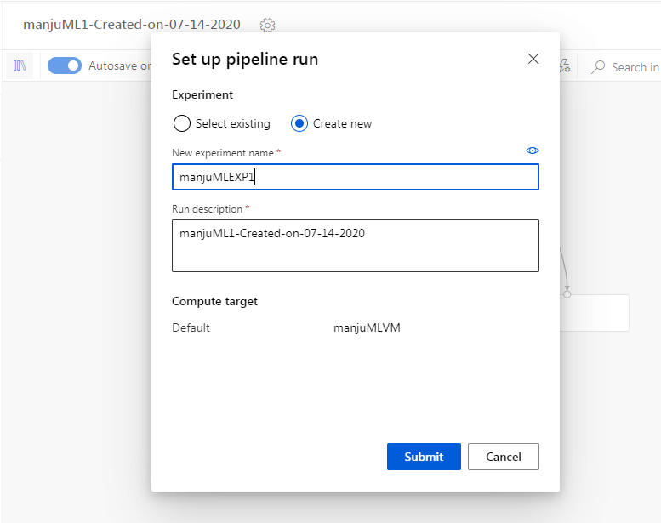

After submitting the pipeline is now running!

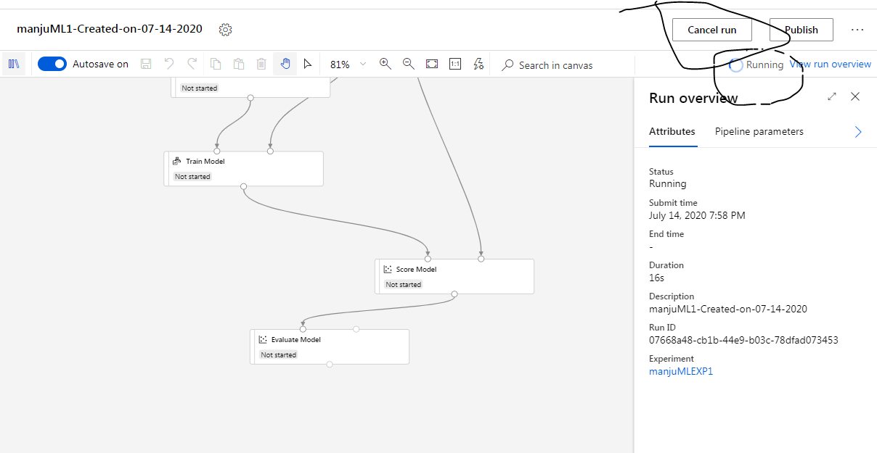

View scored labels

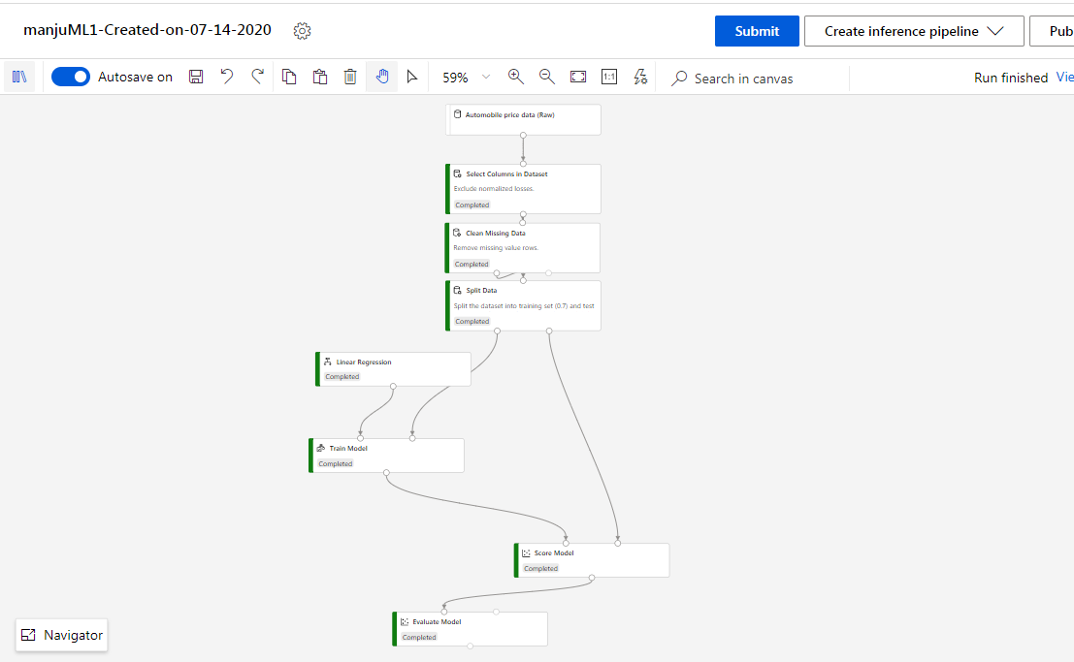

This completes the training and evaluating the model.

**Deploy a machine learning model with the designer**

* Create a real-time inference pipeline.
* Create an inferencing cluster.
* Deploy the real-time endpoint.
* Test the real-time endpoint.

1. Create a real-time inference pipeline

* The trained model is stored as a **Dataset** module in the module palette. You can find it under **My Datasets**.
* Training modules like **Train Model** and **Split Data** are removed.
* The saved trained model is added back into the pipeline.
* **Web Service Input** and **Web Service Output** modules are added. These modules show where user data enters the pipeline and where data is returned.

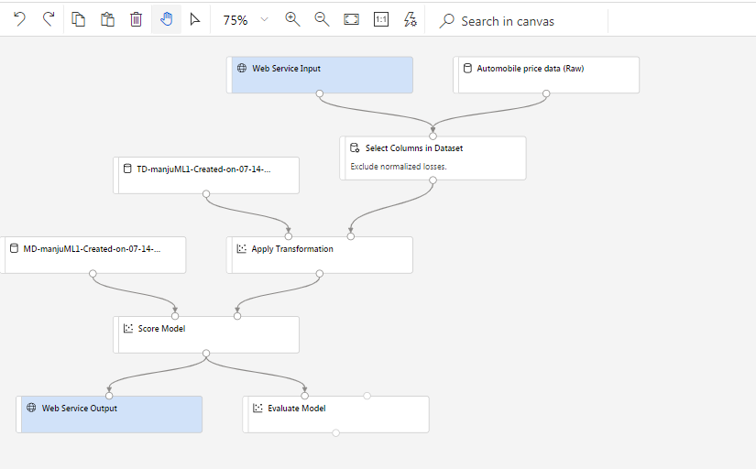

2. Create an inferencing cluster

Deploy the model in azure kubernetes cluster ( AKS)  
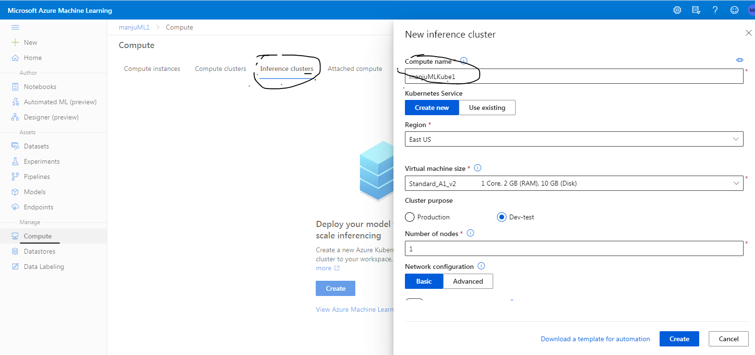

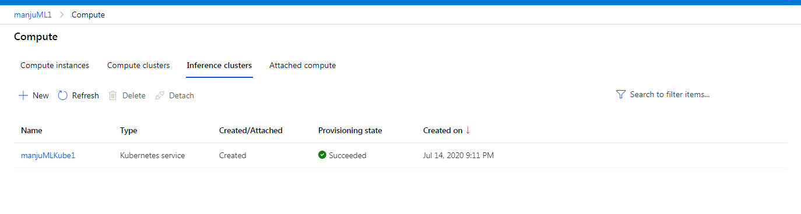 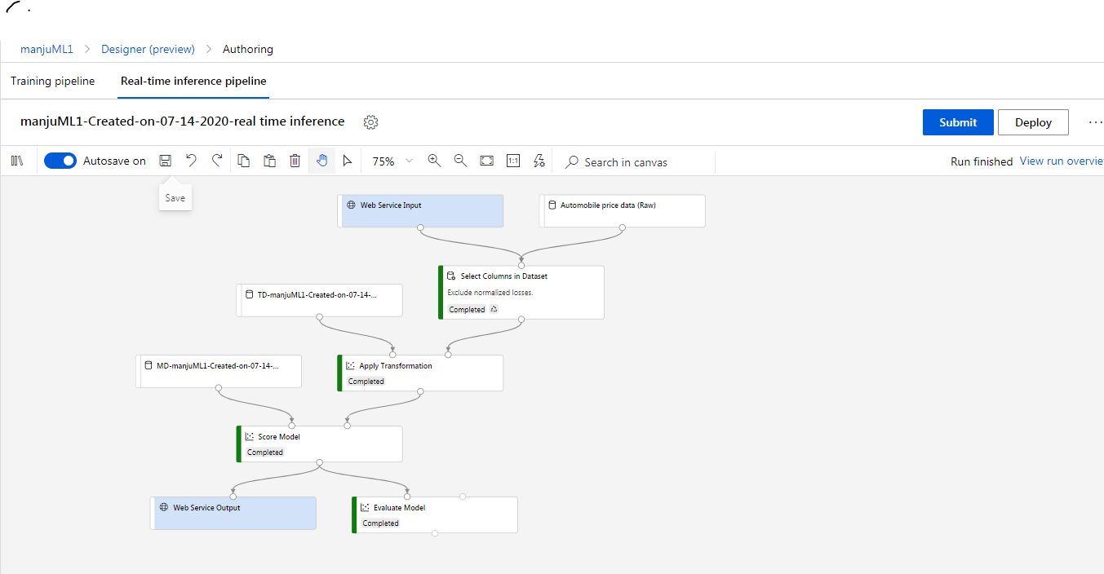  
4. Deploy the real-time endpoint

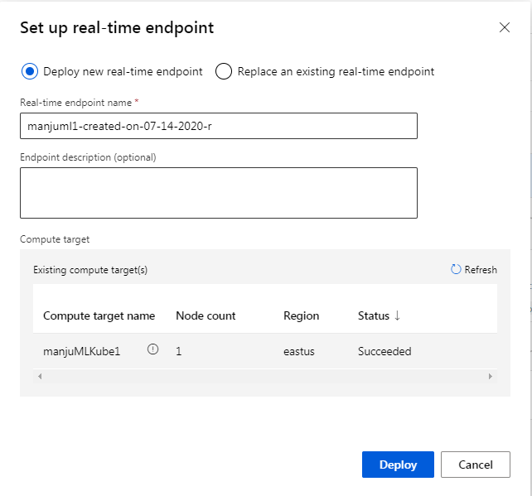

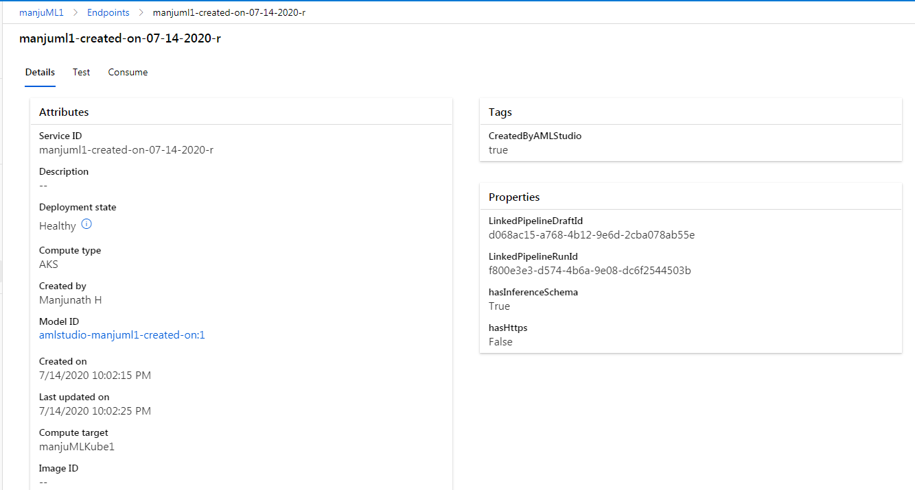

5. Test the real-time endpoint

Rest endpoint : ######

